ER Inversion mbsl Example: Imaging in the Presence of Buried Metal

Overview
The objective of this example is to demonstrate: 1) imaging in the presence of buried metallic objects with known position and dimension, 2) the generation of a custom conductivity distribution outside of E4D, and 3) anisotropic similarity constraints, which encourage conductivity continuity in a user-defined direction. We build upon mbsl mesh generation (mode_ERT1/mbsl), whereby a mesh was generated that contains a buried metallic box, sheet, and line. Users are encouraged to review this before proceeding.
The jupyter notebook ERT3_mbsl.ipynb takes the user through the steps in this tutorial. The file clear_files.ipynb resets the directory to contain files before running ERT3_mbsl.ipynb
The final solution and visualization files are provided in inv.tar.gz.
A jupyter lab notebook is provided within the unzipped directory and show visualization of the results for this example.
We begin by generating the synthetic survey file, which involves 1) defining the conceptual model (i.e., the actual or target conductivity distribution), 2) generating a refined computational mesh to accurately represent the conceptual model, 3) generating a customized conductivity file, and 4) running the forward simulation to generate the synthetic survey file. We then demonstrate two inversions with different inversion options; the first uses standard smoothness constraints, and the second uses blocky constraints with anisotropic weighting and inequality constraints to bound the upper and lower conductivity limits. The visualization in this example demonstrates several different ways in which VisIt can be used to view the mesh and conductivity distributions, although not all visualization options available in VisIt are represented. All files necessary to reproduce the examples are included with the E4D distribution in the directory <e4d_dir>/tutorial/mode_ERT3/metal_box_sheet_line.

Conceptual Model and Forward Simulation
Figure 1 shows the conceptual subsurface conductivity and metal inclusion used in this example. The model consists of a buried metal box and a sheet; these are the same as those incorporated into the mesh in mode_ERT1/metal_box_sheet_line. There is also a dipping plane with a conductivity of 0.01 S/m embedded into a homogeneous background material of 0.001 S/m. Three lines of 48 point electrodes are distributed on the surface as shown.

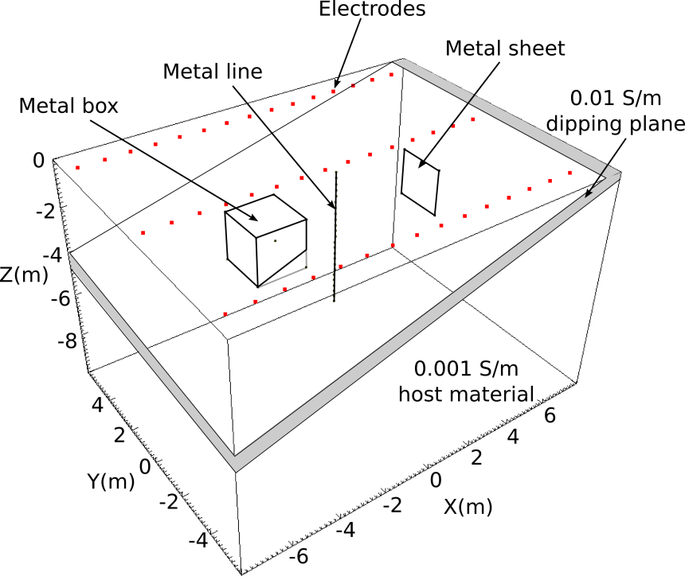
Figure 1. Conceptual model conductivity distribution. The metal sheet is beneath the dipping plane. The metal line and box each penetrate the dipping plane.

Forward Mesh Generation
The conceptual conductivity model can be incorporated into the mesh in one of two ways. First, three zones can be explicitly defined in the mesh configuration file, one for the 0.001 S/m foreground region, one for the 0.01 S/m dipping plane, and one for the 0.001 S/m region that extends to the mesh boundaries (not shown). Because the dipping plane intersects the metallic box, such a mesh configuration file would be complicated in comparison to the original (see file mbsl.cfg). The second option is to generate a conductivity file using the mesh element centroids to assign a conductivity to each element. For example, elements whose centroids fall within the dipping plane will be assigned a conductivity of 0.01 S/m. Elements whose centroids are not within the dipping plane are assigned a conductivity of 0.001 S/m. This approach requires elements that are small enough to adequately represent conceptual model boundaries, but require no modifications to the mbsl.cfg other than changing the maximum element volume limit for zone 1. However, it does require a method of generating the conductivity file outside of E4D. We demonstrate how this may be done in the next section.
As mentioned, to generate a mesh with finely divided elements in zone 1, we change the maximum volume limit (mz_vol) for zone 1 and execute E4D in mode 1 to produce the mesh. In this case, we change the maximum volume from 0.1 m³ to 0.01 m³ in the mesh configuration file mbsl.cfg, as shown in red below. The full mesh configuration file is included with the E4D distribution under <e4d_dir>/tutorial/mode_ERT3/metal_box_sheet_line/mbsl.cfg.
<begin mesh configuration file mbsl.cfg> this line is not included in the file
.
.
.
1 number of holes ... 1 for the metal box(n_holes)
2 -2.5 0.0 -2.5 point inside the metal box
2 number of zones ... 2, 1 for forground and 1 for extension to outer boundaries (n_zones)
1 0.0 0.0 -5.0 0.01 0.002 1 xz_1 yz_1 zz_1 mz_vol_1 cond_1
2 0.0 0.0 -20.0 1e12 0.002
1 flag to build exodus file (bex_flag)
'px' command to build visualization file (bex_loc)

<end mesh configuration file mbsl.cfg> this line is not included in the file
To generate the mesh, E4D is executed in mode ERT1 (see mesh generation documentation). A visualization of the resulting mesh is shown in Figure 2.

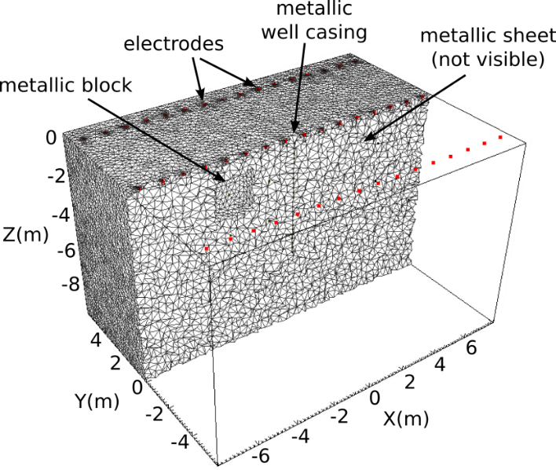
Figure 2. Cut-out view of zone 1 of the forward modeling mesh

Generating a Custom Conductivity Distribution Outside of E4D
Users can generate any desired conductivity distribution using the following the steps:
- Read the mesh node, element, and translation files (i.e., *.node, *.ele, *.trn).
- Use the node, mesh, and translation files to compute the centroid of each element.
- Assign a conductivity value to each element using the element centroids.
- Write the conductivity values to a conductivity file.
An annotated python script that executes each of these steps is included in the E4D distribution, under <e4d_dir>/tutorial/mode_ERT3/metal_box_sheet_line/build_truesig.py, which writes the conductivity distribution to the conductivity file mbsl_truesig.sig. Users may write similar scripts in a language of choice to complete the same function.
Once the conductivity file has been generated, it can be appended to the xdmf file (mbsl.xmf, mbsl.h5) constructed during mesh generation using px. For example, if the conductivity file is named mbsl_truesig.sig, it is appended to mbsl.xmf, mbsl.h5 using the command:
px -af mbsl mbsl_truesig.sig mbsl 1
A visualization of the conductivity distribution produced using the mbsl_truesig.sig on the mbsl.1* mesh is shown in Figure 3.

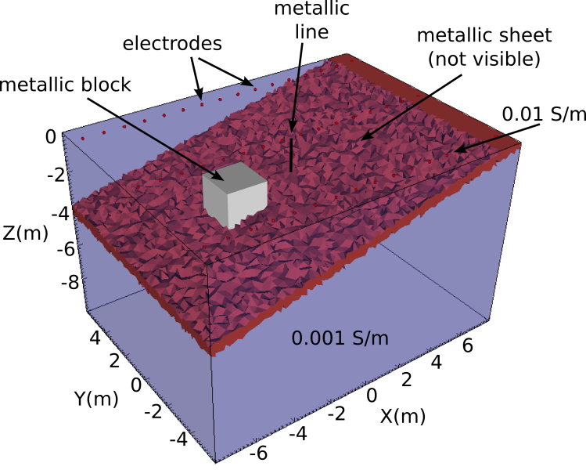
Figure 3. VisIt visualization of the true conductivity distribution representing the conceptual model in Figure 2.

Synthetic Survey File Generation
Now that the conductivity file has been constructed, we are ready to build the synthetic survey file by running E4D in ER forward mode (mode ERT2). In mode ERT2, E4D requires an input survey file, which describes electrode positions and measurement configurations. The measurement values listed in the input survey file are not used in mode ERT2, but must be included in the file. E4D generates an output survey file that includes the simulated measurements for the given conductivity distribution. Hence, the output survey file is named after the conductivity file used for the simulation.
In this example, we use the same survey that was used in two blocks ERT3 in the survey file two_block.srv. However, we must add the metallic structures to the electrode block of the survey file. To do so, we copy two_blocks.srv to mbsl.srv, which will be the input survey file for the forward simulation. We then append the non-point 'electrodes' after the 48 point electrodes previously specified, one for each metallic structure, making 51 electrodes in total as shown below. The entire file is provided with the E4D distribution in <e4d_dir>/tutorial/mode_ERT3/metal_box_sheet_line/mbsl.srv.

<begin input survey file mbsl.srv> this line is not included in the file

51 number of electrodes (48 point and 3 non-point)
1 -7.5 -5.0 0.0 1 electrode_index x y z surface_flag(1 for surface electrode)
.
.
.
49 -4.0 -1.0 -1.0 -1 this is a control point on the metal block (see control pt.61)
50 4.0 -1.0 -1.0 -2 this is a control point on the metal sheet (control pt. 69)
51 0.0 0.0 -0.25 -3 this is a control point on the well casing (see control pt. 125)
2070 number of measurements
1 1 2 3 4 -23.41 1.17 measurement# a b m n V/I st_dev
2 1 2 4 5 -6.03 0.30
.
.
.
<end input survey file mbsl.srv> this line is not included in the file
Although the metal structures are not used as electrodes in this survey, they can be used as either current or potential electrodes through specification in the measurement block in the same manner as a point electrode.
Given the input files as specified above, the corresponding E4D input file for the forward simulation is shown below.

<begin input file e4d.inp> this line is not included in the file

2 run mode
mbsl.1.node mesh node file name
mbsl.srv survey file name
mbsl_truesig.sig conductivity file name
mbsl.out output options file name

<end input file e4d.inp> this line is not included in the file
The forward simulation is executed by running the command (assuming e4d and mpirun are in the executable path):
mpirun -np N e4d
where N is the number of processors to use in the simulation. Note that a single processor cannot compute the pole solutions for both a point and a non-point electrode (see E4D design guide for details). Since there are both point and non-point electrodes in the survey, the minimum number of processors needed to execute the forward run is three; one for the master process, one for the slave process computing the point electrode pole solutions, and one for the slave process computing the non-point electrode pole solutions. The maximum number of processors that can be used is 52, one for the master process and one for each of the 51 electrodes. Thus, N must be at least 3 and at most 52. To give an indication of the compute time required for a forward run, the forward mesh in this simulation has 518,631 elements. The forward simulation executed in approximately 45 seconds on a laptop computer with 8 cores using N=7 (see run_time.txt after executing the simulation).
Upon execution, E4D generates as output the synthetic survey file, which is named mbsl_truesig.sig.srv. In practice, noise should be added to the simulated measurements to represent the desired field conditions, and the standard deviation should be adjusted accordingly (this can be done outside of E4D using a spreadsheet or other applicable software). We renamed mbsl_truesig.sig.srv to mbsl_dipping_plane.srv for use in the inversions below.

Smoothness Constrained Inversion
The mesh used to generate the synthetic data was refined in order to adequately represent the boundaries of the dipping plane. We use a coarsened version of the foward mesh for the inversions, which is produced by changing the maximum volume constraint for zone 1 from 0.01 m³ to 0.1 m³ in mbsl.cfg and running E4D in mode ERT1. Prior to doing so, we renamed the configuration file to mbsl_inv.cfg so that the forward mesh files are not overwritten, thereby producing the inversion mesh files mbsl_inv.1.node, mbls_inv.1.ele, mbls_inv.1.face, mbsl_inv.1.neigh, and mbsl_inv.trn. For reference, the forward mesh contains 518,621 elements, and the inversion mesh contains 95,683 elements. (Note that mesh sizes will vary slightly when generated on different computing systems.) A visualization of the inversion mesh is shown in Figure 4, and is visibly coarser than forward mesh shown in Figure 3.

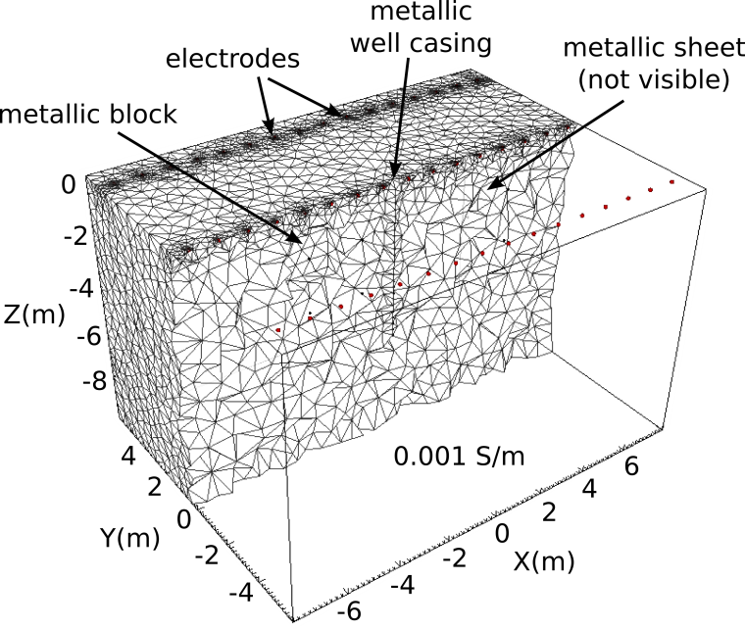
Figure 4: Cut-out view of the inversion mesh mbsl_inv.1* .

To execute a smoothness constrained inversion, we construct an inversion options file with only two constraint blocks, one for zone 1, which is bounded by the black lines in Figure 4, and one for zone 2, which extends to the mesh boundaries (not shown). To implement the smoothness constraints, we use the same structure metric and weighting function as described in the two block ERT3 tutorial. The constraints are shown below in the inversion options file mbsl_1.inv, which is also included in the E4D distribution under <e4d_dir>/tutorial/mode_ERT3/metal_box_sheet_line/mbsl_1.inv.

Inversion Options File: mbsl_1.inv
<begin input survey file mbsl_1.inv> this line is not included in the file

2 # of constraint blocks
1 constrain zone 1 with this block
2 1.0 1.0 1.0 use structural metric 2 (absolute log difference between neighbors)
1 5.0 .05 use weighting function 1 with a large mean
1 2 1 link to zone 2 (i.e. link to zone to using this constraint at the boundary)
0 structure metric 2 does not use a reference value
1 relative weight
2 constrain zone 2 with this block
2 1.0 1.0 1.0 use structural metric 2 (absolute log difference between neighbors)
1 5.0 .01 use weighting function 1 with a large mean
0 no links necessary, already linked to zone 1 in the first constraint block
0 structure metric 2 does not use a reference value
1 relative weight
100 0.25 0.5 start with beta = 100, reduce if % reduction is < 25, reduce by 50%
1.0 target chi-squared value is 1
30 50 minimum of 30 inner iterations, maximum of 50
0.00001 1.0 lower and upper conductivity 'safety' limits
2 do not use line search
1 3.0 use data culling with a residual standard deviation of 3
<end input survey file mbsl_1.inv> this line is not included in the file
The corresponding e4d.inp file is shown below.

Run Configuration File: e4d.inp
<begin input file e4d.inp> this line is not included in the file
3 run mode
mbsl_inv.1.node mesh node file name
mbsl_dipping_plane.srv survey file name
'average' conductivity file name
mbsl.out output options file name
mbsl_1.inv inverse options file name
none no reference file is used
<end input file e4d.inp> this line is not included in the file
The inversion is executed by calling E4D in the usual manner, using between 3 and 52 processing cores as required. Users are encouraged to execute the inversion and review the log file e4d.log. Using the settings given in mbsl_1.inv, the inversion reduces beta three times to 12.5, and converges in 7 iterations. Other notable features of the inversion that have not been discussed previously include:
- Since 'average' was specified for the starting model conductivity, E4D computed the average apparent conducting and used that value for the homogeneous starting model. That value is approximately 0.016 S/m, which is larger than the conductivity of both the background material and the dipping plane, and is caused by the presence of metallic structures. In similar field cases (i.e., in the presence of metallic structures), it may be possible to estimate a more appropriate starting model value— one that is not influenced by the metal.
- Within E4D, a single slave processor can be assigned to more than one electrode, but cannot be assigned both a point electrode and a non-point 'electrode' (i.e., a metal structure). Given this constraint, E4D balances the computations as well as possible. For example, using 7 processors, E4D assigns all three metal structures to one slave process, and divides the 48 point electrodes evenly among the remaining five slave processes (note there are six slaves and one master). Each of these five slave processes is assigned to compute the pole solutions for either 9 or 10 point electrodes.
- The inversion accounts for the metal structures through forward modeling, and does not attempt to image them because their positions and dimensions are assumed known (see E4D theory guide). The inversion estimates the conductivity of the soils surrounding the metal structures, while accounting for the effects of those structures on the observed data through forward modeling.

Visualizations
Figure 5 shows three different visualizations of the inverse solution produced by 1) constructing an visualization file using px and 2) visualizing the file using VisIt. The left-most visualization shows the estimated conductivity structure of zone 1 in the region y > 0. The center visualization adds transparent conductivity isosurfaces to the left-most visualization, and the right-most visualization shows only the transparent isosurfaces.

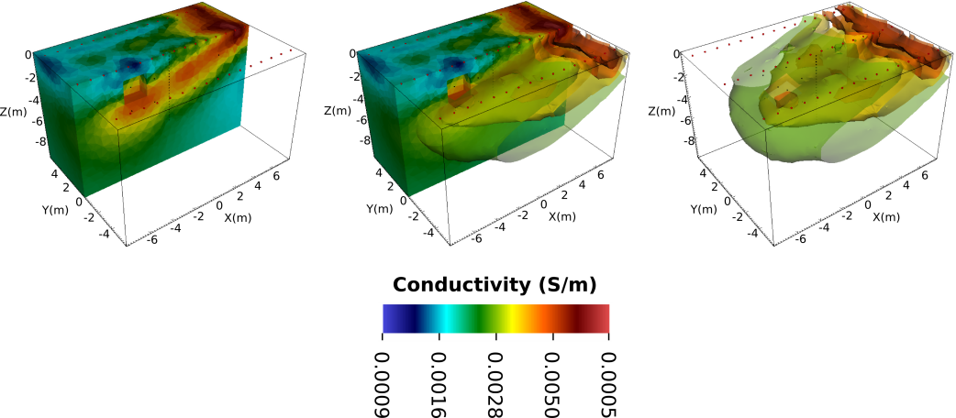
Figure 5. Three different VisIt visualizations of the smoothness constrained inverse solution. Resolution of the planar structure decreases with as the plane move deeper into the subsurface, causing it to ‘disappear’ in the deeper regions. The the conductivities of the metallic structures are not apparent in the inversion results because they are accounted for in the forward modeling step of the inversion (see E4D theory guide).

Anisotropic Weighting and Inequality Constraints
For this inversion we build upon the last by providing, through the constraint blocks in the inversion options file, two additional pieces of information: 1) the orientation of the plane and 2) minimum and maximum conductivity limits. The orientation of the plane is provided with structural metric 6, which provides the absolute difference in log conductivity between adjacent elements, and takes as input a vector normal to the plane of preferred smoothing. Neighboring elements with centroids aligned parallel to the plane are weighted more heavily than elements aligned perpendicular to the plane, thereby fostering continuity along the plane. The minimum and maximum conductivity constraints are implemented as inequality constraints in the same manner as was demonstrated in the two block tutorial. Herein, we set the minimum and maximum conductivity limits to 0.001 S/m and 0.02 S/m. An annotated version of the inversion options file that implements the constraints is shown below. This file is included in the E4D distribution under <e4d_dir>/tutorial/mode_ERT3/metal_box_sheet_line/mbsl_2.inv.

Inversion Options File: mbsl_2.inv
<begin input survey file mbsl_2.inv> this line is not included in the file

4 4 constraint blocks listed below
1 constrain zone 1 with this block
6 0.25 0.0 1.00 use metric 6 to encourage continuity normal to the dipping plane
1 5.0 .02 use weight function 1 with large mean to encourage smooth structure
1 2 apply these constraints at the boundary with zone 2
0 reference value (not used for structure metric 6)
1 relative weight
2 constraint zone 2 with this block (same constraints as zone 1 above)
6 0.25 0.0 1.00
1 5.0 .02
0
0
1
1 constraint zone 1 with this block
3 1.0 1.0 1.0 use structure metric 3 (log(conductivity) - log(reference))
1 0.0 .1 use weighting function 1 to implement a lower bound inequality constraint
0 no links
-6.91 reference value: lower bound = log(0.001) = -6.91
2 double weight for stronger enforcement
1 constrain zone 1 with this block
3 1.0 1.0 1.0 use structure metric 3 (log(conductivity) - log(reference))
2 0.0 0.1 use weighting function 2 to implement an upper bound inequality constraint
0 no links
-3.91 reference value: upper bound = log(.02) = -3.91
2 double weight for stronger enforcement
200 0.25 0.5 start with beta = 200, reduce if % reduction is < 25, reduce by 50%
1.0 target chi-squared value is 1.0
30 50 at least 30 and at most 50 inner iterations
0.00001 1.0 lower and upper conductivity 'safety' limits
2 do not use line search
1 3.0 use data culling with a residual standard deviation of 3

<end input survey file mbsl_2.inv> this line is not included in the file

Run Configuration File: e4d.inp
<begin input file e4d.inp> this line is not included in the file
3 run mode
mbsl_inv.1.node mesh node file name
mbsl_dipping_plane.srv survey file name
'average' conductivity file name
mbsl.out output options file name
mbsl_1.inv inverse options file name
none no reference file is used
<end input file e4d.inp> this line is not included in the file
The inversion is executed by calling E4D in the usual manner, using between 2 and 52 processing cores as required. Users are encouraged to execute the inversion and review the log file e4d.log. In this case, the inversion does not reduce beta from the initial value of 200 and converges in only 2 iterations, compared to 7 iterations for the smoothness constrained inversion.

Visualizations
Three visualizations similar to those shown in Figure 5 are shown below in Figure 6. Resolution of the dipping plane is improved in comparison to the smoothness constrained inversion. Note that blocky boundaries develop on the top and the bottom of the imaged plane, even though weighting function settings for this inversion are the same as those used for the smoothness constrained inversion. The sharp conductivity contrasts at the boundaries of the plane are enabled by the anisotropic weighting, which in this case reduces the similarity constraints normal to the plane, thereby allowing the inversion to place a sharp contrast normal to the plane without penalty. This demonstrates the value of providing the inversion with a priori information in terms of constraining the inversion to improve imaging resolution.

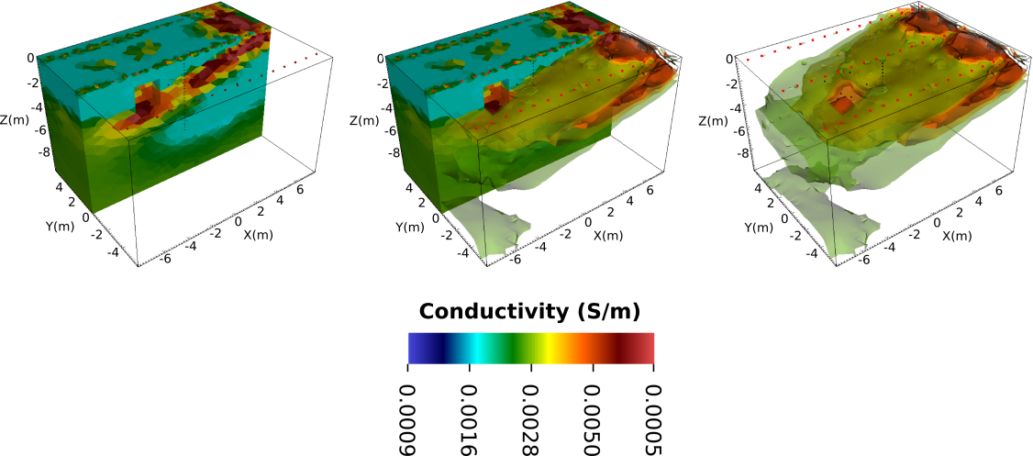
Figure 6. Three visualization of the inversion with anisotropic smoothing and upper and lower conductivity boundary constraint

